**Adithya M PES1UG20CS621 SECTION K**

**Student exercises:**

1. Write a program in ARM7TDMI-ISA to multiply 2 matrices of order3.

i.e., implement c[i][j]=c[i][j] + a[i][j] x b[i][j].

a. Use MLA instruction

.DATA

A: .WORD 1,3,5

B: .WORD 2,4,6

C: .WORD

.TEXT

LDR R5,=A

LDR R6,=B

LDR R7,=C

MOV R3,#3

MOV R0,#0

LOOP:

LDR R1,[R5],#4

LDR R2,[R6],#4

MLA R0,R1,R2,R0

STR R0,[R7]

SUB R3,R3,#1

TEQ R3,#0

BNE LOOP

SWI 0X11

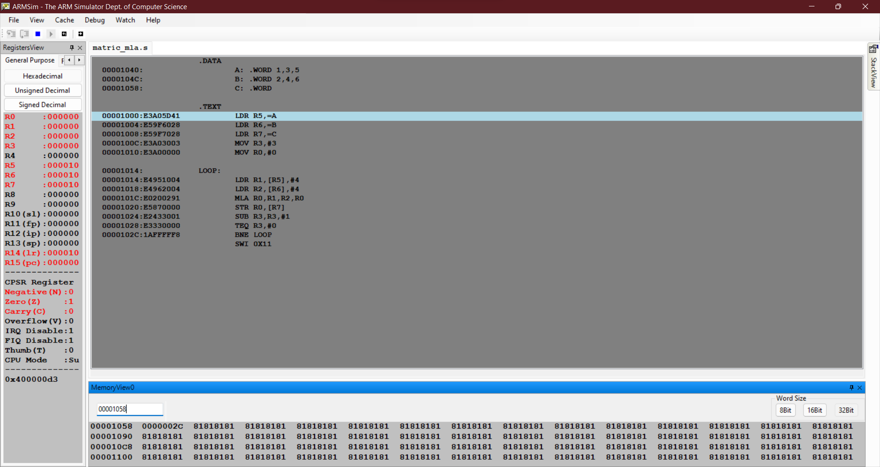

b. Use MUL instruction

.DATA

A: .WORD 1,3,5

B: .WORD 2,4,6

C: .WORD

.TEXT

LDR R5,=A

LDR R6,=B

LDR R7,=C

MOV R3,#3

MOV R4,#0

LOOP:

LDR R1,[R5],#4

LDR R2,[R6],#4

MUL R0,R1,R2

ADD R4,R4,R0

STR R4,[R7],#4

SUB R3,R3,#1

TEQ R3,#0

BNE LOOP

SWI 0X11

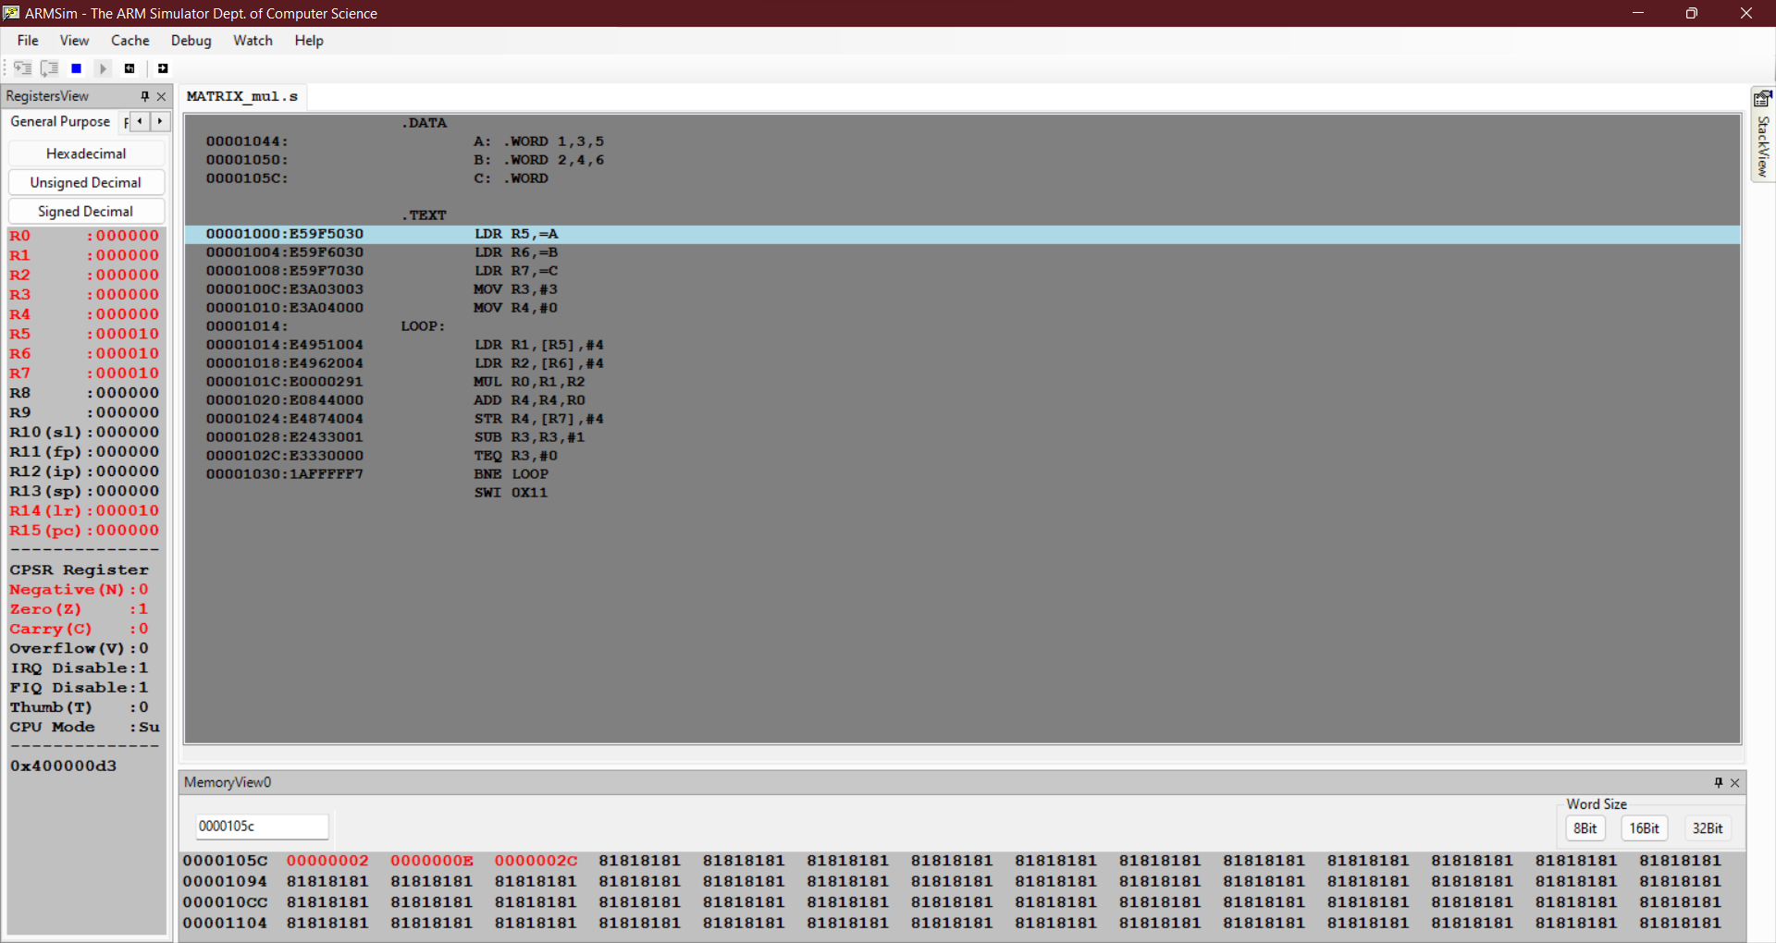

2. Write a program in ARM7TDMI-ISA to find the ROWSUM of a matrix.

.DATA

MAT: .WORD 1, 2, 3, 4, 5, 6, 7, 8, 9

SUM: .WORD

.TEXT

LDR R5,=MAT

LDR R6,=SUM

MOV R0, #3

LOOP:

LDMIA R5,{R2-R4}

ADD R5,R5,#12

ADD R2,R2,R3

ADD R2,R2,R4

STR R2,[R6],#4

SUB R0,R0,#1

TEQ R0,#0

BNE LOOP

SWI 0X11

